To earn full weekly discussion credit, students are expected to comment on all prompts posed by the instructor and provide responses to classmates.

- Each week, you are required to submit a reply to each initial prompt and replies to your peers or instructors in the Discussion Board. The required posts are as follows:
- Any post made in the Discussion Board must be well-developed.
  - A well-developed post is meaningful, shows relevance to the topic, and reflects your knowledge of the material. Well-developed posts demonstrate synthesis of the subject matter, extend the discussion by building on previous posts, and include proper source citations, when applicable. Posts limited to "I agree," "Great posting," or "Thank you" will not be assessed as well-developed, and will therefore not be considered a contribution to the number of required weekly posts.

July 9
Week 5
There is a paper due the same day, look on the bottom

- How do you feel about the MDG initiatives? Discuss ways a community nurse can help with the goals.
Watch this video https://www.youtube.com/watch?time_continue=1&v=Sj6q0Apd_cs
Visit this link to learn more about the Millennium Development Goals.
The goal was to eradicate poverty and the effects of poverty around the world. By 2015, according to the United Nations (2015), "The MDGs helped to lift more than one billion people out of extreme poverty, to make inroads against hunger, to enable more girls to attend school than ever before and to protect our planet."
- Select one of the eight goals and summarize the results according to The Millennium Development Goals Report 2015.
- As a community nurse, what can you do to help with the goal you've chosen?

Reference:
United Nations. (2015). The Millennium Development Goals Report 2015. Retrieved on February 19, 2018 from http://www.un.org/millenniumgoals/2015_MDG_Report/pdf/MDG%202015%20rev%20(July%201).pdf

- Many resources are spent on recruiting foreign nurses. It is a fast-growing private sector business. If the United States and other industrial nations put their resources into fixing the problems that lead to this shortage of nurses, would the need to recruit foreign nurses decrease? Why or why not?
Take a look at this interesting article in a New Zealand nursing journal. They are experiencing similar challenges with their staffing shortage as we are here in the US.
Discussed in the article (attached) is the common concern of graduate RNs finding jobs and having to compete with IQNs for these positions. After reading the article, share your thoughts on this and the overall practice of recruiting foreign-born nurses.
Reference:
Gesmundo, M. (2016). How many IQNs will New Zealand need?. Kai Tiaki Nursing New Zealand, 22(9), 36. Retrieved from https://search.proquest.com/openview/2f64d25837ff7bb17acd1074b9d39eea/1?pq-origsite=gscholar&cbl=856343

July 16
Week 6
- What does professional commitment mean to you? Give an example.
- Do you believe that nurses as lobbyists are essential to the growth of nursing as a profession? Why or why not?

July 23
Week 7
There is a paper due the same day, look on the very bottom and schedule

1. Do you feel that nurses believe that there are ethical concerns related to nursing informatics?

2.Discuss how the use of health information (HI) technology has influenced your current nursing practice. Give examples.

July 30
Week 8
- Do you feel socializing with your colleagues is beneficial in creating a better learning environment? Why or why not?
- What are some key elements in motivating clients to improve health behaviors and outcomes? What role does the family play?

August 6
Week 9
There is a research paper due the same day, look on the very bottom and schedule

Write a summary of your current trend/issue paper for your classmates. Explain why you chose your topic, its current relevance, and the research you found regarding it.

Please do APA format, with in text citations and references

July 23

Week 7: Intelligent Hospital Pavilion ICU Video Analysis/Reflection
Review the Intelligent Hospital Pavilion ICU video at https://youtu.be/V42yuH4xmyQ. Write a paper in which you identify and describe elements that you feel are of benefit or risk to both patients and nurses. Explain the benefits/risks and why you do or do not support this type of available technology. Your paper should be a minimum of three pages and written in APA format with at least two outside credible references.
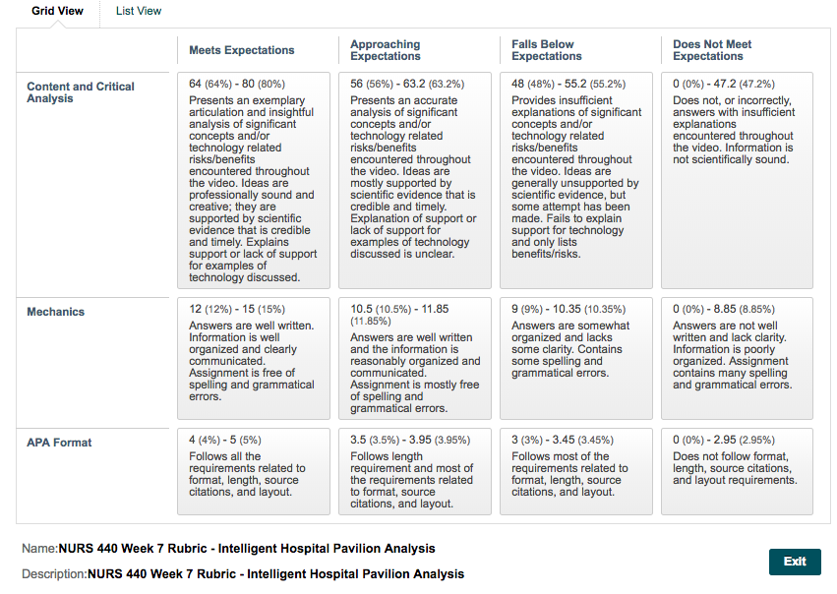

Week 9:
Choose a current issue/trend topic from the following list:
- Technology in health care
- Collective bargaining
- The impaired nurse
- The global nurse workforce
- Mentoring and coaching in nursing
- The trimodal model of 21st-century effective nurse leaders
- Other instructor-approved topic
Create a 6- to 8-page paper in APA format including a minimum of 4 to 5 references. Explain how you would lobby your legislators or local government for funds to support your issue or trend. Include the following elements in your paper: share why you chose the specific topic, the current relevance of material, how it is integrated into clinical practice, and how the information is used in clinical setting.
